## ADAPTIMES SECOND FIELD TRIAL PLAN

*Author: Boyan Bontchev*

*Document created: 27.04.2016*

*Last modification: 05.06.2016*

*Version: 0.4 (draft)*

# Introduction

The ADAPTIMES (ADAPTIve player-centric serious video gaMES)[1] project aims at investigating how cognitive abilities, psycho-emotional processes and playing style can be used as a basis for efficient and effective player-centric adaptivity in serious games. For understanding how these three mental characteristics of the player could be applied for realisation of game adaptivity, the project uses combination of various methods and techniques. Cognitive abilities and processes are tracked while player performs creative and challenging tasks requiring both divergent thinking (for finding various possible solutions) and convergent thinking (for choosing the best solution). On other side, psycho-emotional status and processes and playing style are going to be accessed by means of non-intrusive behavioural measuring techniques like face expression analysis and measuring of electro-dermal activity (EDA) of the player.

The second official video game field trial (FT-2) of the ADAPTIMES research project will use a specially developed set of adaptable educational 3D video games for experimenting how successful could be the gameplay adaptation if based on the ADAPTIMES player-centric adaptation model and to validate its application towards serious player-centric adaptive video games in the area of entrepreneurial education, namely that of strategic management. Adaptation according the playing style is achieved by implicit run time recognition of player’s style during playing a 3D video action mini-game and, next, is used within the educational game for adaptive content selection of learning materials. Adaptation according the player affect is realised in two ways:

* By applying player’s tonic and phasic arousal level inferred by measuring electro-dermal activity of the player using the RAGE arousal detection asset together with a custom hardware device
* By applying player’s emotions inferred in real time on facial expression using a commercial SDK

# Field trial objectives

The objectives of the second field trial of ADAPTIMES project are as follows:

1. To evaluate the effect of affective adaptation:

* over the game usability by using time-to-completion as a measure of efficiency and error rate as a measure of effectiveness (Nacke, 2009, p.173; Sauro & Kindlund, 2005; Law et al., 2008) and, as well, the GEQ
* over the flow using measures of engagement, attention (eye fixation at game objects), and eye saccades (eye closures)

1. To evaluate the implicit in-game measuring of playing styles concerning its construct validity (degree to which this instrument measures the theoretical concept) by finding its correlations of; the concurrent criterion validity of the questionnaire by correlating its performance with current (future) player’s behaviour[2]., and its reliability (the ability of the instrument to create reproducible results – by comparing tests of FT1 and FT2). Both the questionnaire and the game will be reliable, if they reproduce the same results repeatedly:

* test-retest reliability for evaluating stability in three months (sufficiently long to eliminate the practice effect and memorisation, and not too longer because some traits may change with time).
* split-half method for finding internal consistency (ensuring all subparts of the instrument measure the same characteristics – homogeneity, etc.

1. To measure player´s flow, satisfaction and evaluation of game adaptivity concerning:

* Emotion-based adaptivity of generated tasks, DDA and audio-visual effects (illumination, contrast and sound level) – all depending on player’s affect - using:
  + a GUI asset for evaluation of affective adaptivity embedded into the game
  + a post game questionnaire[3] -
* To evaluate playing style adaptivity of generated learning content (learning tasks and questions in the 3D assessment game) using a port game questionnair with q. about playing style and player´s satisfaction and evaluation of style-based adaptivity.

1. To measure player´s satisfaction and evaluation of both:

* adaptive feedback direction (positive or negative) and
* adaptive feedback strength (weak, moderate and strong), in situations of solving puzzles, shooting bullions and finding bullions and keys!, and their correlations with player style

1. To measure dynamic in-game detection of playing styles - by comparing detected style to that one calculated via the style questionnaire.
2. To measure game engagement according the impact of the game adaptivity - by a modified GEQ, and to find correlations with the in-game reported engagement and attention.
3. To measure game learnability & learning outcomes - by comparing two groups of students.

Additional secondary goals:

1. To find descriptive statistics of the EDA tonic signal (SCL amplitude) and phasic signal (SCR amplitude, number of peaks and area under curve) components during specific key game events[4] such as missing/succeeding to hit/solve/discover an object (like bar of gold), namely:

* when solving puzzles: at wrong and right answer submission, at increasing and reducing puzzle difficulty (player will see the diff. level! in order to make a stronger imprint on him/her) -
* when shooting bullions - at unsuccessful and successful hits, at increasing and reducing hitting difficulty
* when finding bullions or tunnel keys

2. To find correlations between EDA tonic and phasic signal components and player emotions inferred using facial expressions in real time

# Foundations

3.1 ADAPTIMES model for player-centric based adaptation

The ADAPTIMES model for player-centric based adaptation is based on three main sub-models representing the player-centric basis of adaptation:

* Model of cognitive player character – based on **player performance** (results shown throw-out playing time) including both player’s knowledge and intellectual abilities represented by synthetic, analytical and practical skills. Player performance are tracked and, based on it, game challenges (both the game mechanics and dynamics) provided by the game will be adapted – task difficulty is increased with growing player performance (mission success) for various types of tasks
* Model of affective player character – based on **player emotional (affective) state** and concerning player emotions and motivation. Players emotions will be inferred based on face expression analysis provided by third party and used to calculate moving average of the emotion of happiness, fear, surprise and disgust and to adapt both game dynamics and aesthetics;
* Model of conative player character – based on **playing style** and depending on player’s personality and styles of thinking.

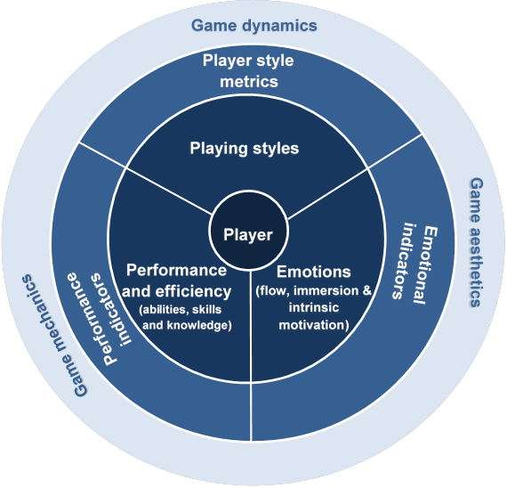

Fig. 1: The ADAPTIMES player model

Player performance, player emotional (affective) state and playing style form the three central pillars (bases) of a holistic player model for achieving an efficient adaptation for enhanced playability. They are closely interconnected each other and should be used as a whole but not in isolation. In fact, all they are used as player’s responses for realization of the game adaptation process resulting in possible adjustments in features of game mechanics, dynamics and aesthetics as represented in fig. 1. The adjusted features provide stimuli to further changes in player’s state, which on their turn are expressed as new responses.

Therefore, measuring of any type of player’s characteristics should be done in an implicit way, inconspicuous and invisible for the player. Such an implicit derivation of player model (i.e. assessment of the player) may rely on measuring visible changes in player state and behaviour the game adaptation engine will infer about eventual changes in cognitive, affective, and conative player state (fig 2), as follows:

(1) Performance indicators will serve for measuring player’s performance and, hence, for estimating player’s abilities, skills and knowledge – the indicator type will vary on the nature of the skill/ability or knowledge considered. For example, motor skills (behavioral and physical skills) can be measured by game metrics like successful hits, number of goals/levels achieved, enemies killed, etc. On the other hand, intellectual skills can be measured by number of problems solved or by time needed for problem resolution. Player´s performance includes total effectiveness and average difficulty of solved tasks, while player´s efficiency is calculated as ratio between attained result and spent effort for achieving that result;

(2) Facial or voice expressions, psychophysiological indicators and/or measures of the central neural system can be used for inferring player’s emotions and, hence, levels of player’s flow, immersion and intrinsic motivation;

(3) For dynamic recognition of playing styles, in particular the ADOPTA styles, the model uses linear regression of specific player metrics obtained by behavioral interactions during the game and depending on specific game context. As a whole, these metrics include:

* player result (i.e. effectiveness or performance) achieved in accomplishing a task related to specific player style – e.g., number of struck objects might serve as a metric for calculation of shooter style;
* average player efficiency in accomplishing a task related to specific player style – e.g., ratio between number of struck objects and total number of shots might serve as a metric for calculation of shooter style;
* attained average difficulty of accomplished task – provided the task difficulty is variable during the game.

Next, identified changes in cognitive, affective, and conative player state are used (all together or separately) for adapting various types of game issues (fig. 2), including the following:

(1) game mechanics – adjustment of explicit, implicit, or player-driven game tasks and their managed appearance in the game flow (Sweetser and Wyeth, 2005) and non-linear narrative; as far as goals, feedback, rules for obtaining action points, moving within the game, taking greater/lower risk, etc.;

(2) game dynamics – like adaptation of difficulty according to the player’s anxiety (Rani et al, 2005);

(3) game audio-visual properties evoking emotional responses (i.e., game aesthetics), like adjustment of ambient light in rooms in a video game (Grigore et al, 2008).

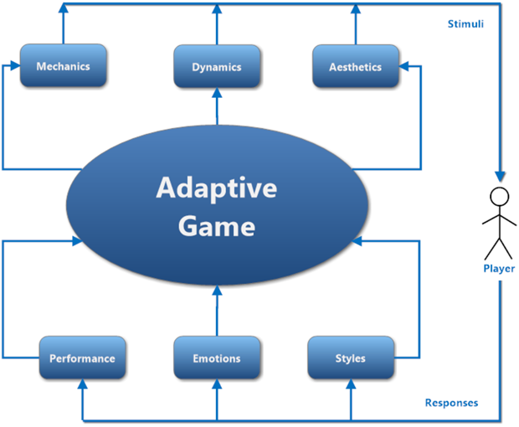

Fig. 2: The ADAPTIMES principal adaptation process (ADAPTIMES D2, 2015)

3.2 ADAPTIMES workflow

Player-centric modeling investigates and measures the human behavior and allows researchers and game designers to adapt the game mechanics according important features of the player’s character. The ADAPTIMES principal workflow of game adaptation control generalizes the frame idea of Charles et al (2005) for applying player type and player preferences for monitoring player performance as presented in fig. 3. Here, the player type is replaced by an enhanced player’s model including playing style, emotions and performance. Player preferences, together with player goals, are to be used predominantly for static game personalization. In contrast with that, the player model serves for monitoring of overall player’s behavior unlike (Charles et al, 2005) where only player style is monitored, i.e. the model defines exactly what and how to be monitored in terms of space and time. Measurement of the effectiveness of dynamic online adaptation is used for updating the player model and, next, for adapting specific game features according eventual changes in player character. Moreover, individual player feedback is collected and analyzed in real time, instead of traditional methods using self-reports. For example, this could be achieved by means of an adaptation control asset making part of the asset panel of the video game. More precisely, the player communicates his/her appraisal of both direction (negative or positive) and the level (such as low, middle or high) of the present game adaptation, which will allow to the adaptation engine to calibrate the adaptation parameters for this individual player. As well, the adaptation engine may use machine-learning approaches in order to predict the optimal adaptation needed for players with specific instance of the model (i.e. having specific performance, emotional state and playing style).

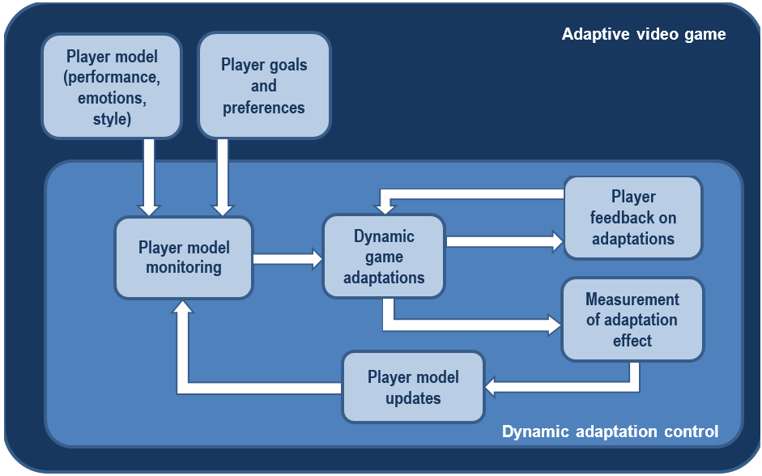

Fig. 3: The ADAPTIMES principal workflow for game adaptation control

3.3 ADAPTIMES playing styles

The playing style family used in the model is based on the Kolb’s experiential learning model, which is based on a pedagogical approach of ‘learning by doing’. Kolb's learning styles are organised in a two-dimensional space, where the abscise axis represents the Processing Continuum (how a person approaches a task – observing or doing it) and the ordinate axis Perception Continuum (how he/she thinks or feels about a task, i.e. his/her emotional response). The two axes represent four possible polarities, which can be described pair-wise:

* Concrete Experience – CE (feeling) versus Abstract Conceptualization – AC (thinking)
* Active Experimentation – AE (doing) versus Reflective Observation – RO (watching)

The possible combinations between the pairs reveal four types of learning styles, namely:

* Diverging (CE+RO)
* Assimilating (AC+RO)
* Converging (AC+AE)
* Accommodating (CE+AE)

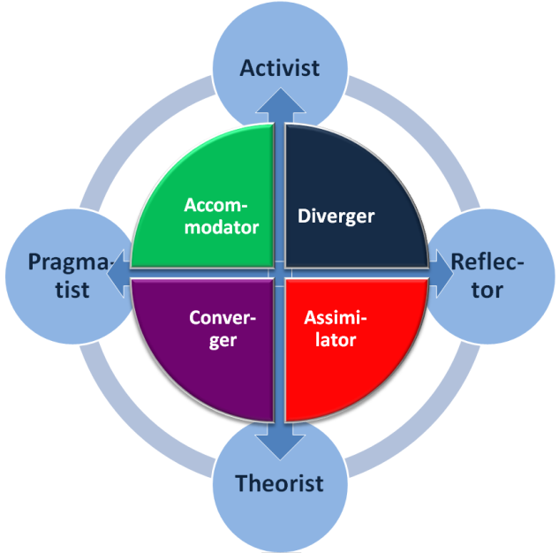

Fig. 4. Learning styles of Kolb versus styles of Honey and Mumford (Vassileva and Bontchev, 2012))

The Honey and Mumford’s model is based on the theory of Kolb according to which learning process has two bipolar dimensions - perception (y axis in fig. 4) and processing of information (x axis). Thus, four styles can be formed by this two-dimensional coordinate system, where one of them is often dominant to the other styles. The model includes the following four predefined learning styles: *activist* (fond of new ideas and experiments and looking for challenges of practical tasks rather than listening to lessons), *reflector* (preferring to observe subjects from different perspectives and to reflect about their characters), *theorist* (opposite to activist, looking for formalization, concepts and logical theories) and *pragmatist* (opposite to reflector, prefers to apply theoretical ideas into practice). Fig. 4 represents graphically relations between learning styles of Kolb (in internal circle) and Honey and Mumford found in (Munoz-Seca and Silva Santiago, 2003). The activist matches Kolb’s styles of accommodator and diverger and feeds from concrete experience, while the theorist corresponds to converger and assimilator and benefits from abstract conceptualization. The pragmatist corresponds to accommodator and converger and looks for active experimentation, while the reflector is stacked to diverger and assimilators and prefers reflective observation.

The learning styles of Honey and Mumford are widely used within pedagogical strategies for adaptive learning. Therefore, the learning stylistic character is polymorphic as far as it is represented by levels of affiliation to several learning styles. These levels are determined by a specific style test performed before starting adaptive learning.

The ADOPTA project (Aleksieva-Petrova et al, 2011) proposed a playing style family based on Kolb´s cycle and including: logician style (*watch & think*) - gaming and learning activity include spatial awareness and usage of verbal and numeracy skills; dreamer style (*feel & watch*) - embraces problem solving and lateral thinking plus collaborative skills, social interaction and negotiation; competitor style (*feel & do*) - supposes hand–eye coordination, teamwork and ability to think quickly; strategist (*think & do*) - likes planning, decision-making, testing hypotheses, strategic thinking, and management skills. Unlike other families of playing styles (ADAPTIMES D1, 2015), the ADOPTA styles are directly based on the Kolb learning model and have strong correlation with Honey and Mumford styles (Bontchev, 2016), which makes them appropriate for style-based adaptation in educational games.

Unlike using traditional self-report methods, individual playing style is calculated implicitly during the play process, without player to be aware of it. This novel approach for implicit determination of the playing style during the game playing time is based on specific game play metrics, appropriate for measuring given playing style by tracking their values during the playing process. Calculated playing style was used for adaptation of game content and dynamics within the mini-game “Rush for Gold” (FT-1) and, after been validated, will be used for game dynamics, mechanics and aesthetics adaptation within an educational maze game (FT-2).

# The field trial video games

The field trial will be dedicated to experimental game-based learning with an educational 3D maze video game named STRAMAG (STRAtegic MAnagement Game) for teaching basics in strategic management together with several other video games embedded into the maze:

* Rush for Gold – a 3D video game using adaptation based on player performance, efficiency and emotional state, used for implicit recognition of ADOPTA playing styles
* 3D assessment game - a 3D video game using adaptation based on emotional state of the player, used for assessment in the didactic area (strategic management)
* 3D zoom ordering game - a 3D video game using adaptation based on emotional state of the player, used for special orientation and contextual thinking

All of the 3D video games are developed over the Brainstorm eStudio platform. Tey are desktop games running on Windows platforms. Affect-based adaptivity in games is realised using two technologies:

1. facial expressions emotion inference provided by a Web service accessing Face Analysis Cloud Engine of SightCorp[5];
2. 2.3D RAGE game asset Real-Time Arousal Detection Using Galvanic Skin Response – by measuring players’ EDA using a cheap custom device and inferring current level of both tonic and phasic arousal[6].

The structure of the game modules is presented at fig. 5. Both the emotion recognizer and arousal asset are integrated into the games using socket interfaces (for achieving better performance) and run at the same machine. Players start first with the “Rush for Gold” adaptive game in order to be possible to recognize their playing style in an implicit way using specific gameplay metrics. After finishing this game, they are transferred automatically to the STRAMAG game, where they start learning concepts in strategic management and doing learning tasks adapted towards the style. As well, they can play 3D assessment and 3D zoom ordering games, in order to collect points and next to use them for navigation through the tunnels inside the maze.

DDL

USB

TCP sockets

Fig. 5: Structure of the game modules

4.1 Rush for Gold

4.1.1 Game objectives

The video mini-game (RUSH FOR GOLD) with player-centric adaptation will have as a *main goal implicit recognition of individual playing style and its explicit validation*. This recognition will be supported by game adaptivity based on both player's performance and emotional status inferred according face expressions taken once per second. The mini-game aims at collecting all the 12 gold bars (bullions) within a 3D space representing a huge temple (fig. 6 and 7). The 12 bars of gold are either hidden, flying or staying behind puzzle images with logic tasks. Any collected bar of gold is automatically rotated to the right orientation and put on the wall. The goal is to reach the final result as shown in fig. 8.

The RUSH FOR GOLD game provides three challenges to the player concerning finding/discovering and collecting all the 3D gold bars (i.e. items) within a 3D space representing a huge temple, where there are three groups of items:

* Group A: These items are flying high near the ceiling – the player cannot rise up to their elevation and can see them only from bellow; the only way to get them is to shoot them from bellow and to hit and drop it off to the bottom, in order to click on it and collect it (fig. 7). Difficulty of shooting (linear and angular velocity of the flying bullions and defeat range of the bullet are adjusting by both player performance and emotional state.

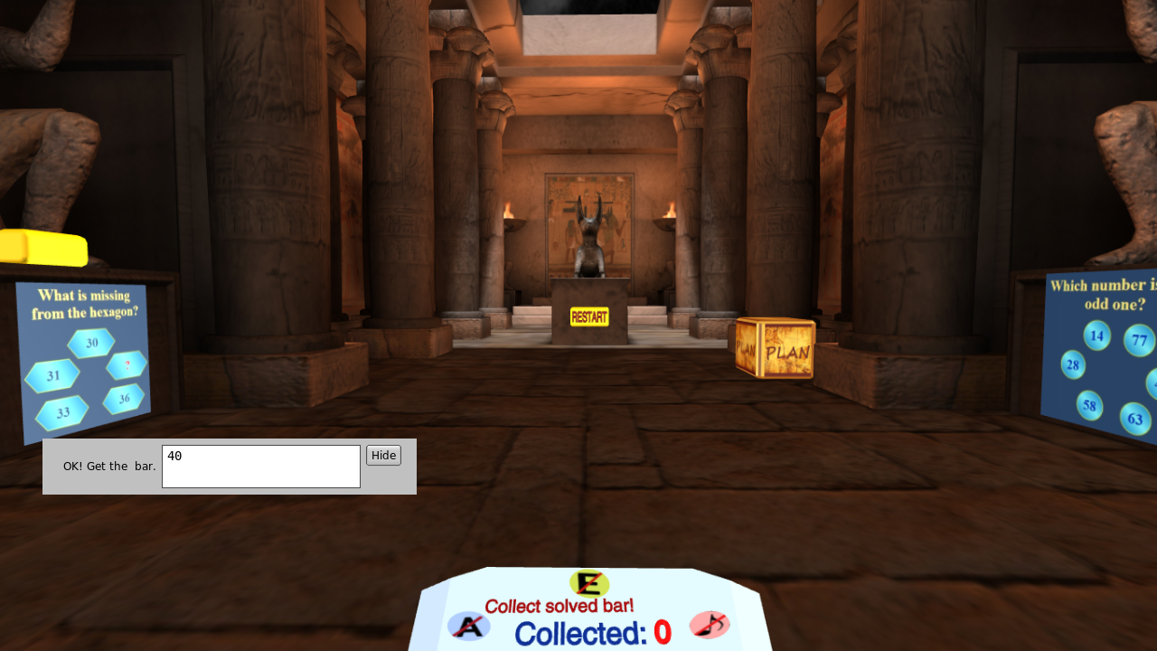

Fig. 6: A view of the game with a solved puzzle and its shown gold bar (left)

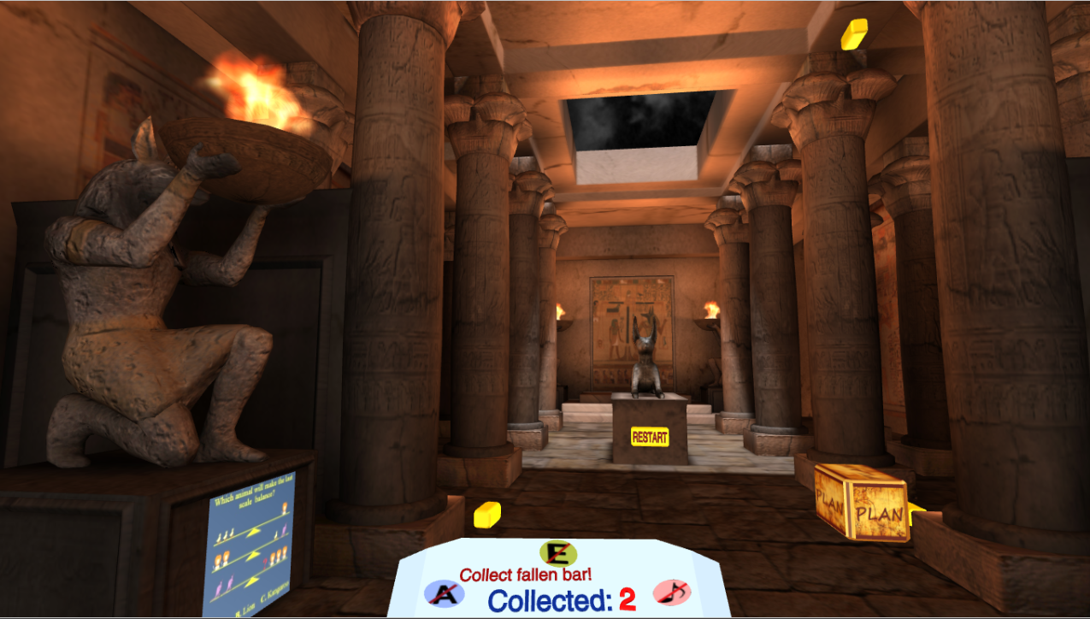

Fig. 7: A view of the game with a fallen gold bar (centre), a flying gold bar (right over) and a shown gold bar (right down)

* Group B: These items are dispersed on the floor of the room and some of them are hidden behind the columns of the temple. The player has to explore the whole temple in order to discover them and, next, to hit each item in order to collect it (fig. 7). Difficulty of discovering is adjusting by both player performance and emotional state.
* Group C: These items are to be obtained after finding a correct answer of a rebus. The rebus is shown on images hanged on the walls of two monuments. The solution is a number or a text and will be checked for correctness after been submitted on the box near the image (fig. 6). Solving difficulty of each next puzzle is adjusting by both player performance and emotional state.

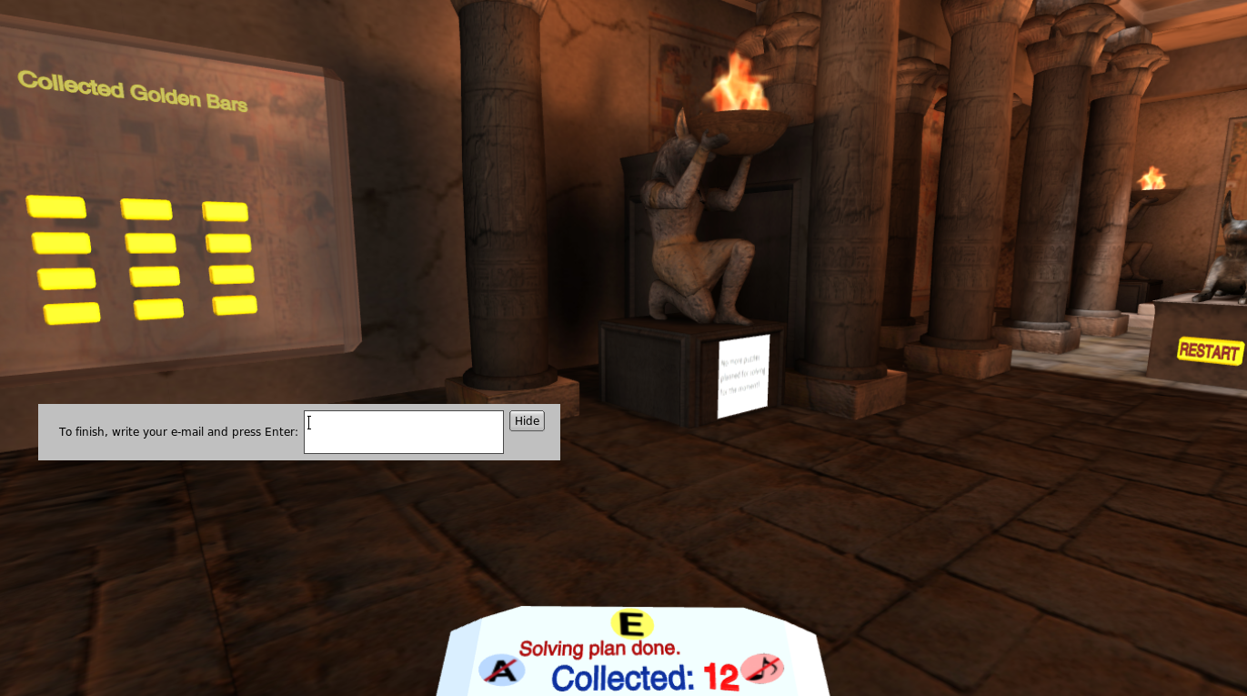

Fig. 8: 12 gold bars collected

4.1.2 Game scenario

Initially, the mini-game shoes a help board explaining the goal and how to navigate within the game (fig. 9), which should be pressed to start the game (after pressing on it it goes to the wall and can be consulted at any time), starts with two items of each of groups A, B and C, The player chooses which type of items will try to collect first. Each successfully collected bar of gold will provoke appearance of a new bar of the same group until reaching 50% of the total number (i.e. 6 of 12) gold bars collected from the same group. E.g., if the player will start shooting one of the flying items and will hit it, the item will fall down, the player should collect it (by clicking on it) and a new flying item will appear to be shot, until reaching 50% of the total number of items. For each collected bar of gold, the player will get a point.

After reaching 50% of items being from the same group, items of the other groups appear only. The player should start trying to collect them. For each collected item of given group, a new item of the same group appears until reaching 4 bars. Last 2 bars will be from the third group. Thus, there should be collected at least 2 bars of each group.

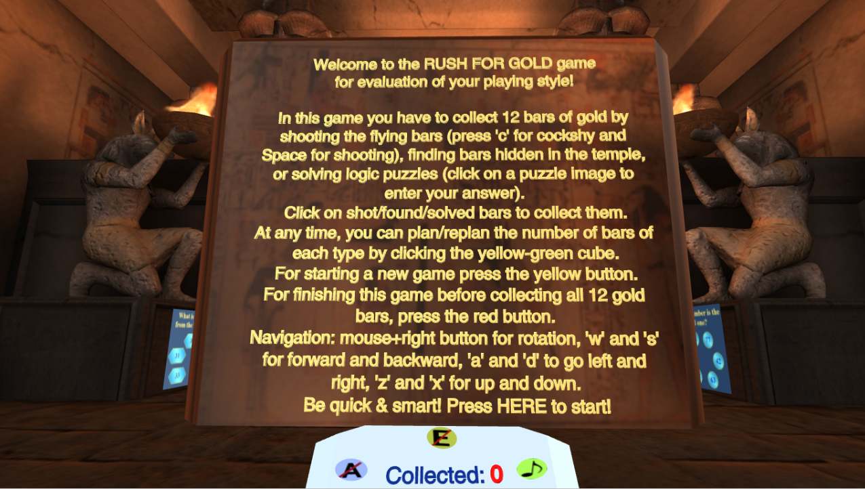

Fig. 9: Start of the “Rush for Gold” game

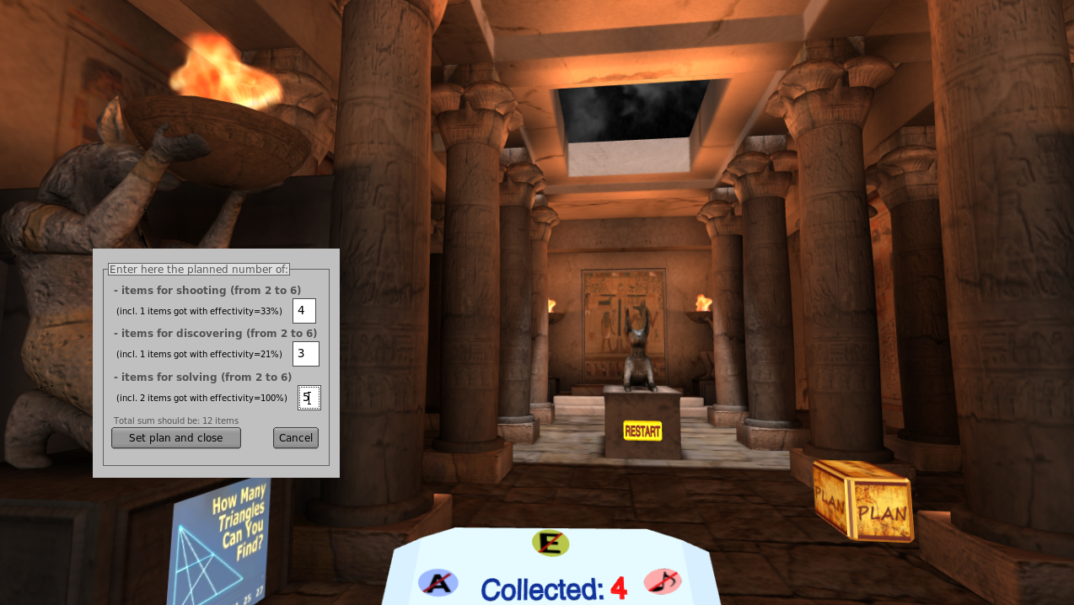

Fig. 10: Planning the gold bars using a Strategy Management Table

From the very beginning of the mini-game, the player will be confronted to a so called Strategy Management Table (SMT) representing a table with three rows for planning percentage of puzzle items of Groups A, B and C (fig. 10). As well, SMT will contain data about average effectivity (AE) of performance for collecting the gold bars of each group, namely:

* for Group A – number of hit bars divided to total number of shots;
* for Group B – number of found bars divided to the number of passes near a hidden item until realizing and collecting it;
* for Group B - number of right answers divided to total number of answers.

The gained points P in the mini-games will equal to the number of bars of gold.

After collecting all the 12 gold bars, or before this moment if the FINISH button is clicked, the game estimates the playing styles and shows them to the player as given in fig. 11. The styles are calculated as well of the player finishes the game before collecting all the 12 bars (by clicking the red ball). All results about playing styles are written to a log file in order to be compared to these obtained by filing a playing styles questionnaire. In fact, three fog files are supported:

* A log file with data about calculation of the playing styles
* An event log file – contains all the game events with timestamps and related values
* An affect log file – contains all the EDA and arousal data received from the RAGE asset, as far as the emotion vectors received by SightCorp Web service.

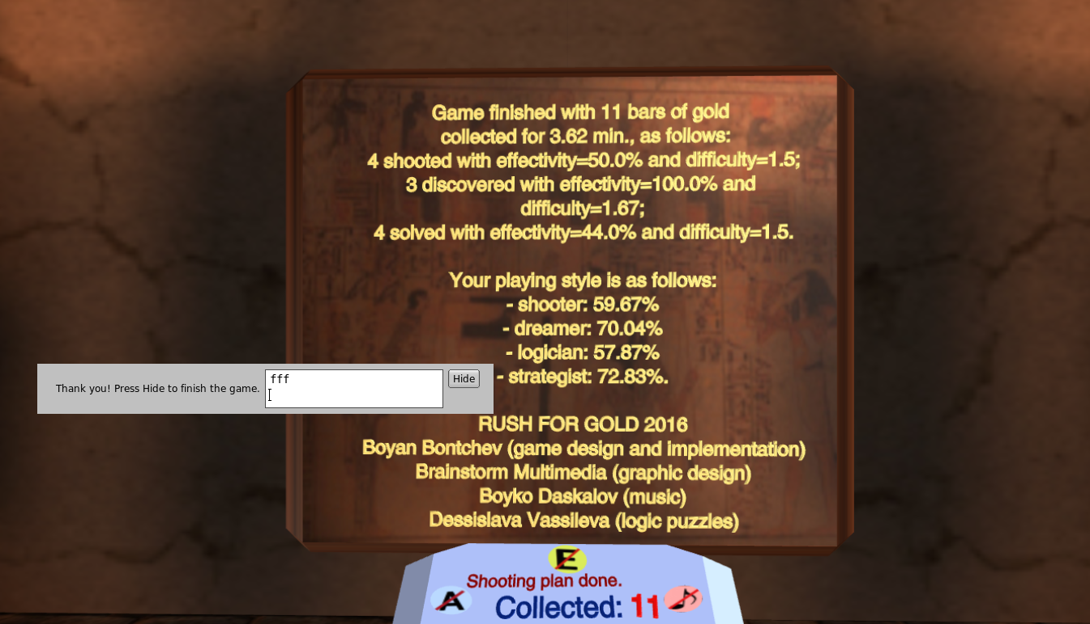

Fig. 11: Finishing before collecting all the 12 gold bars (by pressing the FINISH button)

After finishting the “Rush for Gold” adaptive video game, the player is directed to the STRAMAG game.

4.2 STRAMAG

Educational games for higher education are still not a popular mean for teaching. Simple drill-and-practice computer games can be useful but are not enough for massive game-based learning. Free software tools for creation of educational games should be available for domain specialists, in order to create easily new educational video games. However, there is a lack of customizable and cheap video games/platforms for teaching young people by means of video games.

STRAMAG (STRAtegic MAnagement Game) is a 3D maze desktop game for entrepreneurial education, especially in the area of strategic management. Game design and part of the game content is developed by Boyan Bontchev within the scope of the ADAPTIMES project. In fact, the maze of STRAMAG is generated using a specialized software tool for generation of educational maze game (Bontchev, 2015) serving for easy creation and customization of 3D video mazes incorporating unlimited number of maze rooms connected each other via tunnels. The tool is based on the Brainstorm eStudio platform and API[7] and uses a custom basic game engine still sufficient for educational maze games. It is intended to help game-based learning, far not only in the entrepreneurship domain. Teachers can construct 3D video mazes by using the graph editor and, next, can customize rooms for any domain through the property editor (fig. 12). The property editor sets values to pre-defined and fixed set of properties, however, for the next version will be controlled by property metadata.

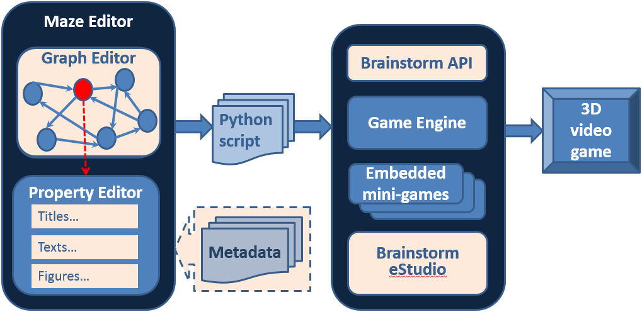

Fig. 12: A platform for generation of customizable video maze games for education

By video games based on customized 3D mazes students are able to learn new ideas, concepts and theories while navigating within the maze. Naturally, maze-based learning alone could be boring and therefore not efficient. This can be avoided by embedding into the maze game various mini-games such as for developing fine-motor brain skills, visual and spatial thinking and context-based reasoning. In the context of entrepreneurship education, all these will foster entrepreneurial creativity. The embedded mini-games might be mainly entertainment games or might provide additional didactic value.

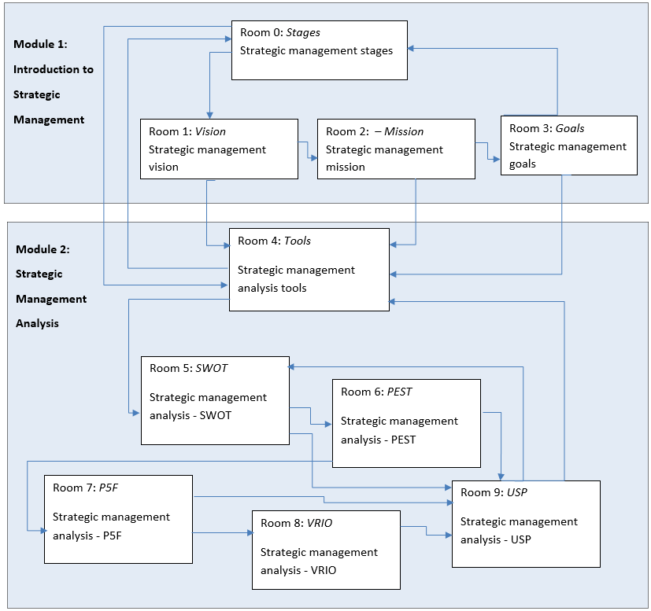

Fig. 13: State transition diagram of the STRAMAG maze game

STRAMAG integrates key excerpts of learning content about Strategic Management such as about the formulation and implementation of the major goals and initiatives taken by a company's top management, based on the consideration of resources and the assessment of the internal and external environments. All the learning content is arranged by Dr. Sia Tsolova from the Dep. of Software Technologies at Sofia University, Bulgaria. Music is created especially for the game by Boyko Daskalov, while the free sound effects incorporated within the game are from SoundBible.com.

The STRAMAG maze contains 10 teaching rooms customized by the property editor in terms of forms, color and textures. Fig. 13 represents a state-transition diagram of the STRAMAG maze game. The rooms are distributed into two modules:

1. *Module 1: Introduction to strategic management*
   1. Room 0: Stages in strategic management
   2. Room 1: Vision - Strategic management vision
   3. Room 2: Mission - Strategic management mission
   4. Room 3: Goals Strategic management goals
2. *Module 2: Strategic management analysis*
   1. Room 4: Strategic management analysis tools
   2. Room 5: SWOT - Strategic management analysis – SWOT (Strengths, Weaknesses, Opportunities and Threads)
   3. Room 6: PEST - Strategic management analysis – PEST (Political, Economic, Social, Technology)
   4. Room 7: P5F - Strategic management analysis - P5F (Porter's five forces)
   5. Room 8: VRIO - Strategic management analysis – VRIO (Value, Rarity, Imitability, Organisation)
   6. Room 9: USP - Strategic management analysis – USP (Unique Selling Proposition)

Each maze room contains boards for learning and help content as far as image frames. Both textual and graphic didactic content is specified in a declarative way using the property editor (fig. 12). Fig. 14 shows a screenshot of the initial room (Stages) of the STRAMAG maze. It presents the front panel containing introduction to the game and instruction for playing, and text and image board (left and right) containing learning contents specified in declarative way using the property editor.

Besides the lesson (learning content), the room contains an adapted learning task that is chosen specially for the predominant learning style of the player (thanks to the high correlation between the player style and the learning style, because both are based on the Kolb experiential learning model). This is achieved by embedding into the game learning tasks for all possible learning styles and, next, by choosing a task being most appropriate for the learning style of the individual player. For this purpose, the Python script contains tasks for each of the learning styles – Activist, Reflector, Theorist, and Pragmatist. Fig. 15 presents a learning task chosen for the Reflector learning style

Thus, STRAMAG realizes adaptive content selection based on the playing/learning style determined during the game in an implicit for the player way.

The player navigates through the maze from one learning room to another following a navigation tunnel connecting the two rooms. Connecting arrows in fig. 13 represents such tunnels. For entering the tunnel, the player has to click on a button showing the name of the target room (e.g., the “Vision” button shown on the left side below in fig. 14). When entering a tunnel, the total number of points decreases with 25.

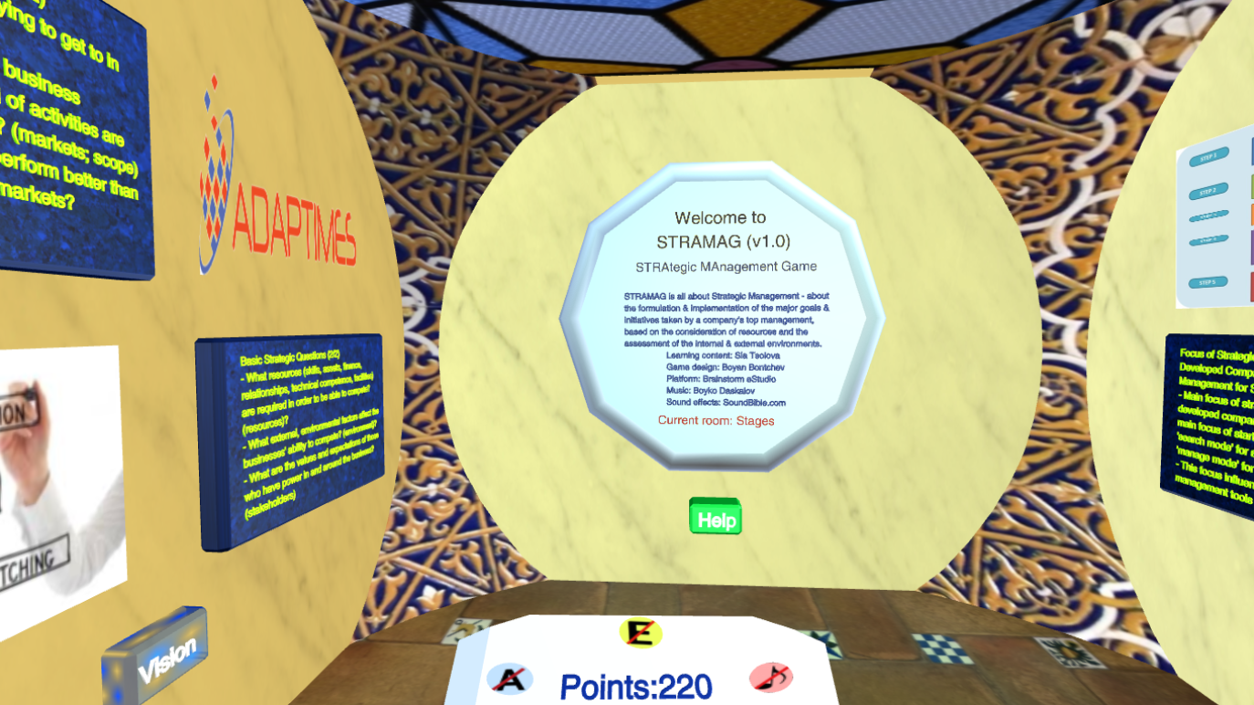

Fig. 14: A view of the initial room (named Stages) of the STRAMAG maze.

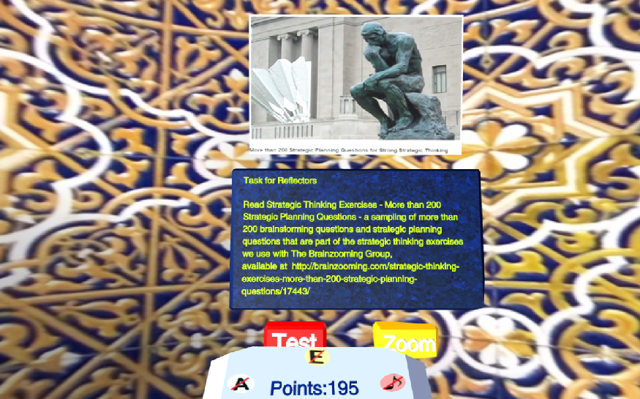

Fig. 15: A learning task chosen for the Reflector learning style

STRAMAG supports three types of navigation tunnels:

* Free tunnels (fig. 16) – the player is instructed to click the key presented next to the information board. After being clicked, the key flies to the key lock (fig. 17) and should be clicked again in order to turn in the lock and to open the door to the next maze room.

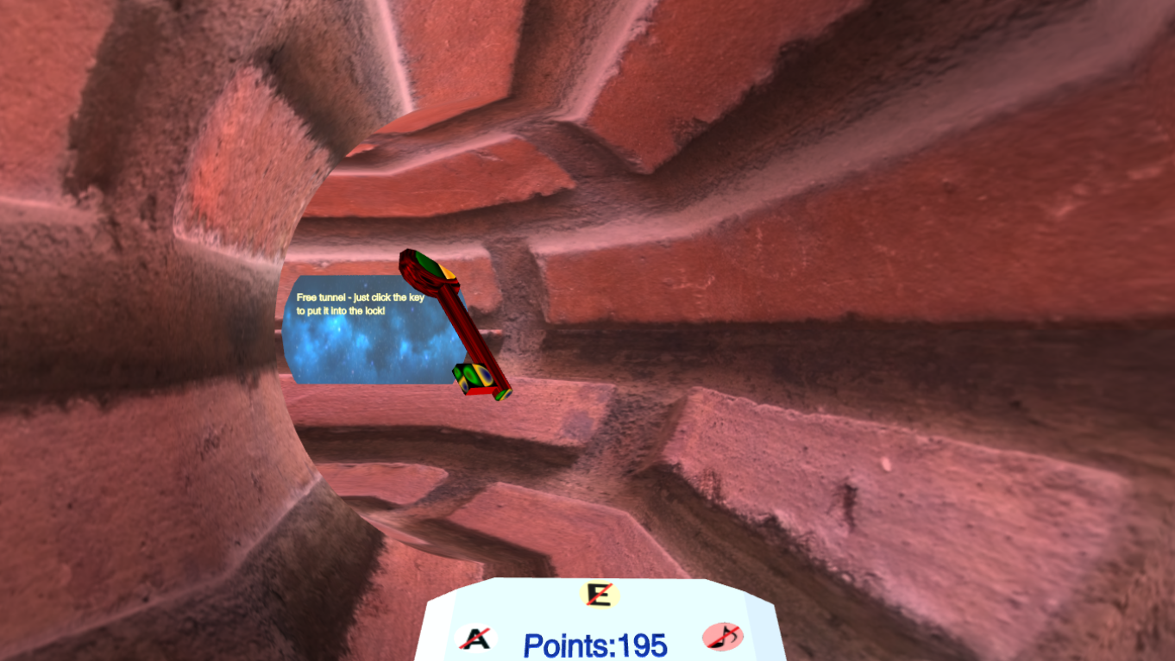

Fig. 16: A free navigation tunnel – key is to be clicked in order to fly to the key lock

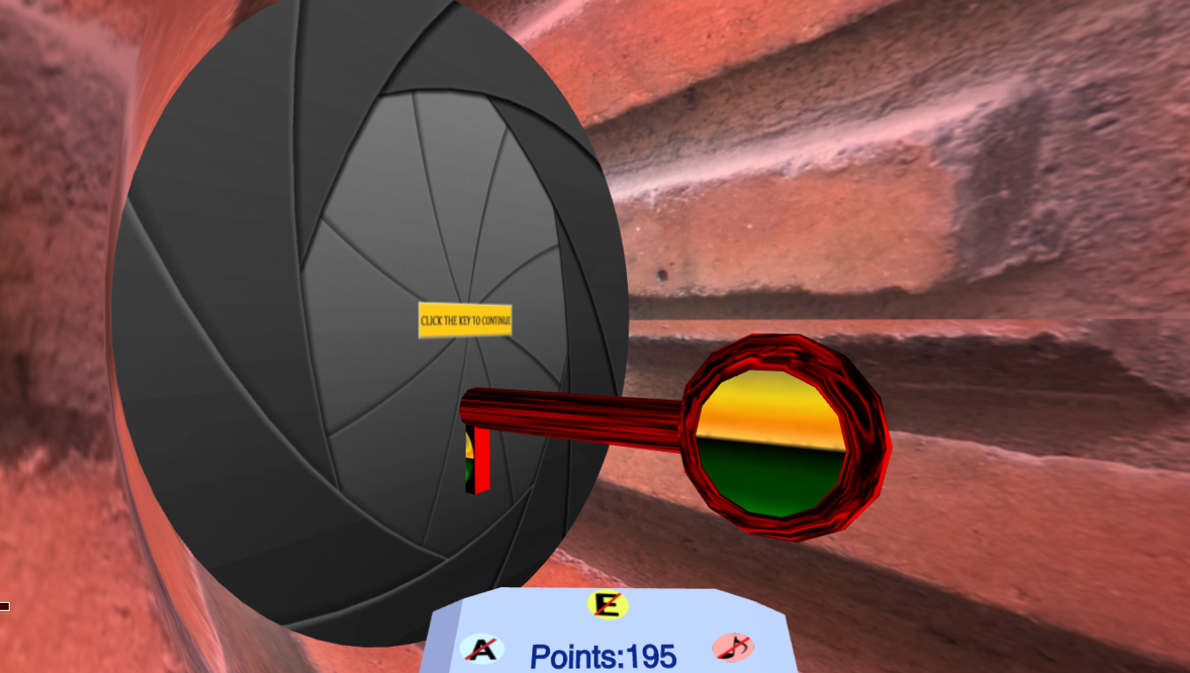

Fig. 17: The key is put into the key lock and has to be clicked for entering next room

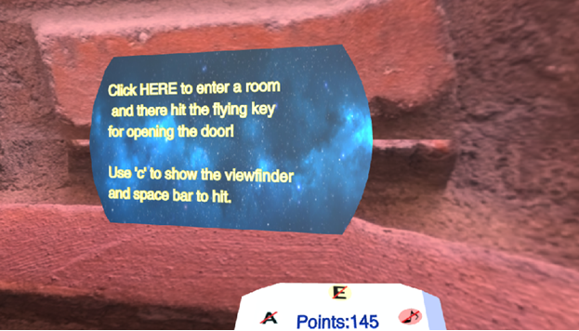

Fig. 18: A tunnel with shooting tasks (appropriate for Competitors)

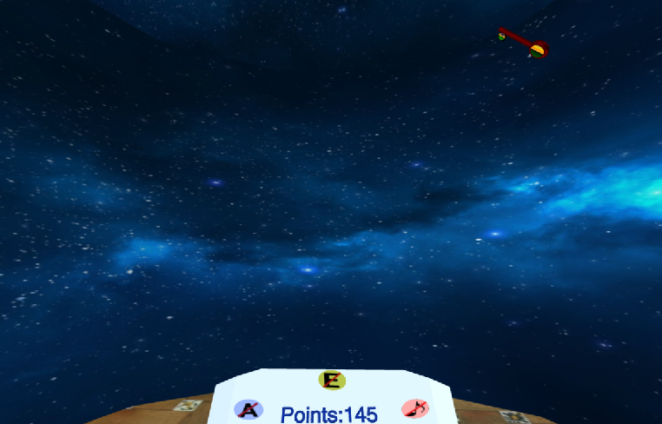

Fig. 19: A shooting room – the player has to hit the flying key (a Competitor task)

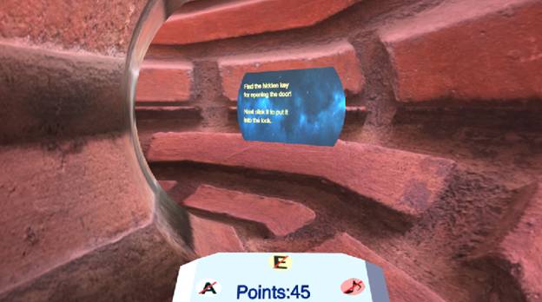

Fig. 20: A tunnel with hidden key to be found (a task for Dreamers)

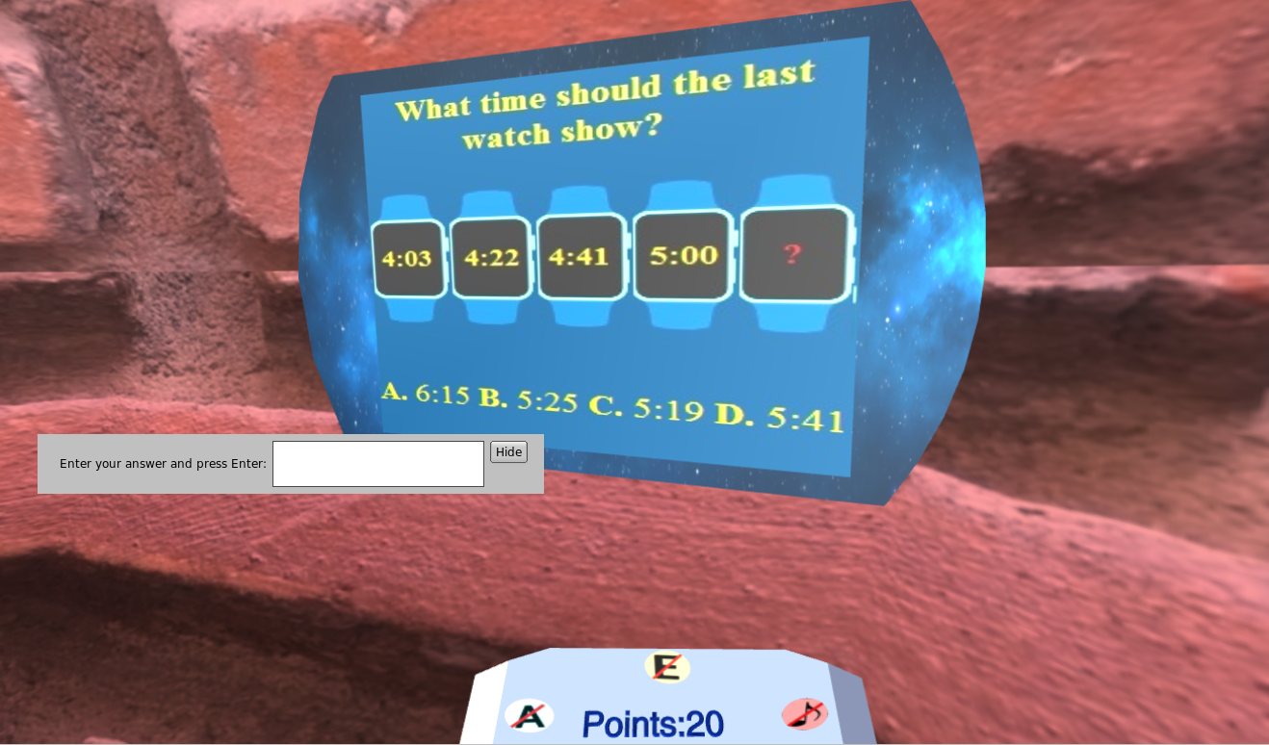

Fig. 21: A tunnel with a puzzle to be solved (a task for Logicians)

* tunnels containing a shooting task (adapted to Competitors) – in such a tunnel (fig. 18), the player is instructed how to enter a shooting room (fig. 19) for hitting a flying key in order to proceed to next room
* tunnels containing a task for Dreamers – in such a tunnel (fig. 20), the player is instructed to look for a hidden key and click on it in order to proceed to next room
* tunnels containing a solving task (adapted to Logicians) – in such a tunnel (fig. 21), the player is shown a puzzle to be solved in order to get the key

At each transition from one room to another, the points are decreased by 25. Therefore, after certain number of transitions the player appears to run out of points. Fig. 22 shows a situation, where playing points are under the limit and the player cannot proceed to next room. In such a case, the player has to enter another game for collecting new points sufficient to proceed within the STRAMAG maze. For this purpose, he/she has to navigate either to the 3D assessment game (by pressing the “Test” button in fig. 15) for making a test, or to the 3D zoom ordering game to start ordering context-dependent pictures (by pressing the “Zoom” button in fig. 15).

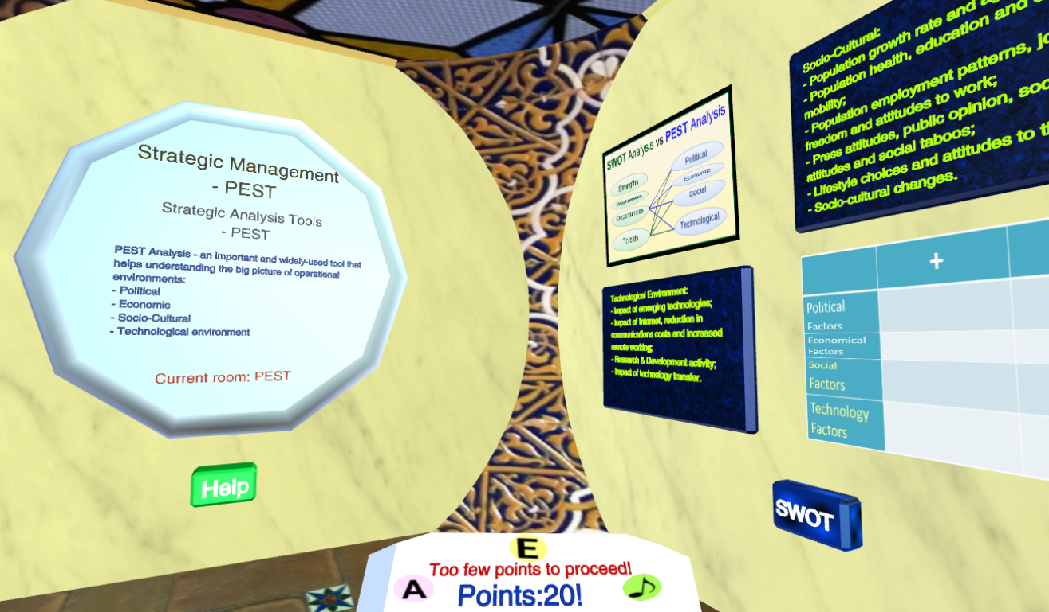

Fig. 22: Playing points are under the limit and the player cannot proceed to next room

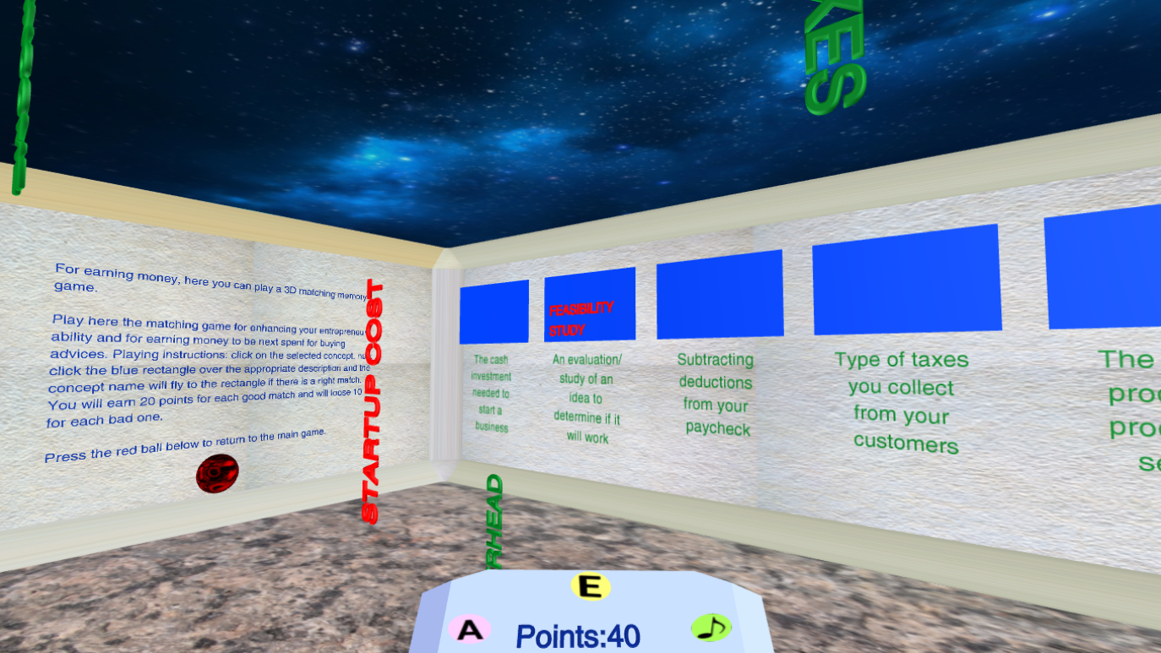

Fig. 23: A view of the 3D assessment game

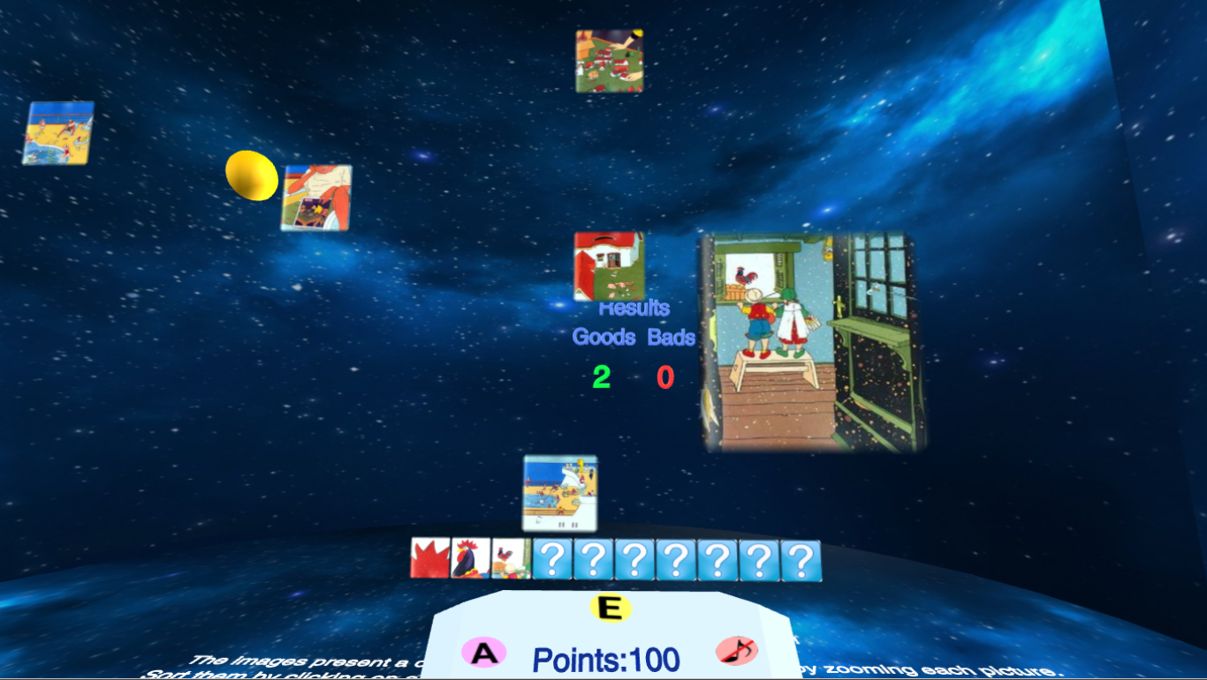

Fig. 24: A view of the 3D zoom ordering game

4.3 TEST – a 3D assessment game

The player can enter the TEST game (a 3D assessment game) by pressing the “Test” button in fig. 15) for making a short test over the learning material. As a mini-game for winning points in order next to invest them in learning while traversing the maze, TEST is realized as a dynamic 3D matching game selected due to its didactic value. It is customized with questions and answers about basic concepts in the learning area, in order to ask students to select their correct definitions and to make them understand more deeply their meaning and correct use. The player has to select a concept (shown in green flying text in fig. 23) by clicking on it, whereupon the text is enlarged and changes its colour from red to green (such as the STARTUP COST label in fig. 23). Next, the player should select the right answer on the right wall by clicking on it, whereupon the concept label flows to the blue area situated over the answer.

Both the linear and angular velocity of the flying concepts are subject of affective adaptation, as explained below.

4.4 ZOOM – a 3D zoom ordering game

For entering the ZOOM games, the player has to press the “Zoom” button (fig. 15). The ZOOM mini-game is for ordering moving images from the famous illustrated zoomed sequence of Istvan Banyai. This game was embedded into the maze thanks to its advantages regarding development of context-dependable thinking and visual orientation. Students see an unordered sequence of pictures taken by zooming an initial image. They have to order the zoomed images by considering their different contexts based on coincidence of some of the details at consequent images. Unlike use of still images (traditional for game-based learning in entrepreneurship), here the unordered image move from left to right and back with different velocities. The player selects a moving image by clicking on it, which make the image to appear in bigger size. Next, the player should click on the appropriate position in the ordered sequence (below in fig. 24). If the image position within the sequence is correct, the selected image flies down and the good points increase by one. Otherwise, the image recovers its original size and continues moving, while the bad points are incremented.

The linear velocity of the flying picture is subject of affective adaptation, as explained below.

# Adaptive gameplay

5.1 Gameplay adaptation based on player performance

In “Rush for Gold” game and in tunnels of the STRAMAG game, adaptation of gameplay is based on dynamic adjustment of task difficulties for the shooting, puzzle solving and gold bars discovering tasks. In “Rush for Gold”, all the three tasks start with difficulty level equal to 1. Next, the performance-based adaptation is as follows:

1. After each shot bar, the current shooting effectivity is evaluated as one divided to numbers of hits shot for this bar.

* If the current shooting effectivity is less than a threshold (let say, 50%), next bar for shooting will have a lower difficulty level or the same difficulty level in case of 1.
* If the current shooting effectivity is equal or greater than the threshold, next bar for shooting will require a difficulty higher by 1. Therefore, for the maximum number of 6 bars for shooting, the max difficulty can be not exceed 6. The shooting difficulty depends on two parameters:
  1. Precision of shooting (higher difficulty means higher precision)
  2. Velocity of flying bars (higher difficulty means higher velocity)

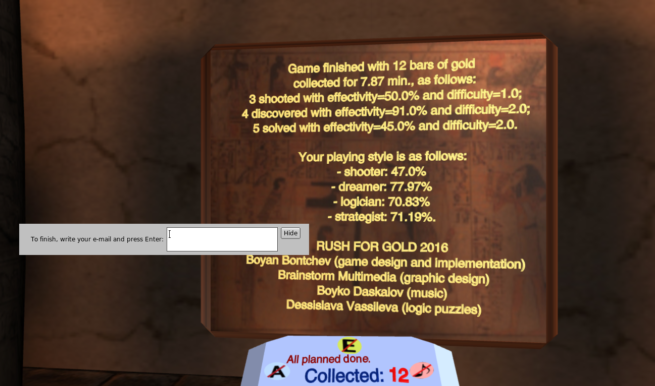

Fig. 25: Game finish with 12 gold bars collected

1. After each discovered gold bar, the current discovering effectivity is evaluated:

* If the discovering effectivity is less than a threshold (let say, 50%), next bar for discovering will a lower difficulty level or the same difficulty level in case of 1. In other words, it will be easier or not harder than the previous bar to be discovered.
* If the current shooting effectivity is equal or greater than the threshold, next bar for discovering will require a difficulty higher by 1, i.e. will be harder to be discovered. Therefore, for the maximum number of 6 bars for discovering, the max difficulty can be not exceed 6.

1. After each gold bar got by solving a puzzle, the current solving effectivity is evaluated:

* If the solving effectivity is less than a threshold (let say, 50%), next bar for solving will a lower difficulty level or the same difficulty level in case of 1. In other words, it will be easier or not harder than the previous bar to be solved.
* If the current solving effectivity is equal or greater than the threshold, next bar for solving will require a difficulty higher by 1, i.e. will be harder to be solved. Therefore, for the maximum number of 6 bars for solving, the max difficulty can not exceed 6.

For this purpose, the game contains:

* a sufficient number of puzzles with given solving difficulty
* a sufficient number of bar locations with given discovering difficulty

Both mean effectivity and mean difficulty for shooting, discovering and solving tasks are shown in the end of the game (fig. 25) and used for calculation of the playing style.

5.2 Gameplay adaptation based on player affect

5.2.1 Player’s emotions inferred using facial expressions

There are estimated the most popular discrete emotions used in systems for expression recognitions - the Big Six basic emotions: “happiness”, “sadness”, “fear”, “anger”, “disgust” and “surprise”, as proposed by Ekman in 1969. The purpose is to keep the player in the flow zone (fig. 26).

The levels of “happiness” (“joy”), “fear”, “anger”, “disgust” and “surprise” are used for keeping the player in flow. A performance-based adjusting of difficulty is maintained using the values of the “fear”, “anger” and “surprise” emotions, as follows:

* If one of them is less than the threshold of 20%, than difficulty level is set to 1 (in positive feedback mode)
* If one of them is less between 20% and 40%, than difficulty level is set to 2 (in positive feedback mode)
* If one of them is greater than the threshold of 40%, than difficulty level is set to 3 (in positive feedback mode)

The levels of difficulty level 1, 2 and 3 are not absolute, but depend on the strength and direction of the affective adaptation feedback, as explained in section 3.4. By default, the strength of affective adaptation is set to +2 (positive moderate).

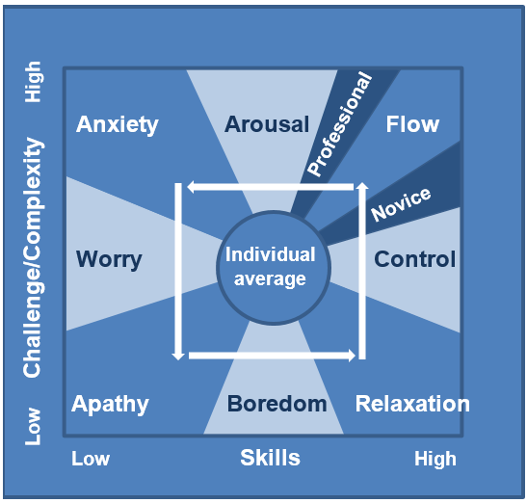

Fig. 26: Mental state as function of challenge and player’s ability/skills

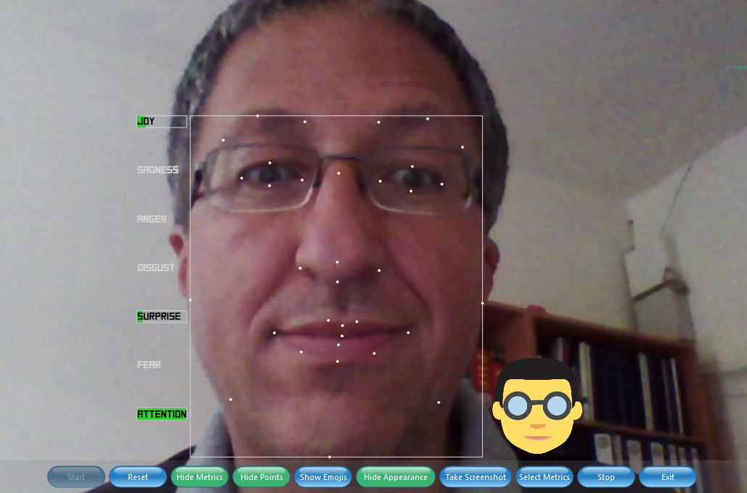

Fig. 27: A screenshot of the emotion recogniser with found joy, surprise and attention

The performance-based adaptation is controlled by player’s emotions estimated by means of face expressions analysed each 15 times each sec, i.e. applying a rate of 15Hz (no greater rate is needed). The estimation software is a client side application using video stream produced by the Web camera of the computer/laptop. The application uses SDK of Affectiva[8] and communicates recognized values of emotion levels (in percentage) through a socket interface (fig. 27).

Data about the six basic emotions (in %) are averaged within a moving window of 10s, together with data about more complex emotional states (in %) such as:

* Engagement
* Attention (based on eye fixation)
* Eye closure (based on eye saccades)

After finishing the game session, engagement and attention are going to be compared to these reported in the self-reports.

Adjustment of difficulty based on emotions inferred by facial expression is non-obtrusive, however, have some drawbacks when emotions are intentionally expressed and exaggerated, suppressed or even hidden during the observation, which varies between cultures, races and social environments (Garrod et al., 2012). That´s why emotions inferred by facial expression are combined with one psychophysiological measurement – that of electro-dermal activity (EDA).

5.2.2 Player’s arousal inferred using EDA

Besides emotions inferred on player’s facial expressions, the game uses player’s arousal inferred using EDA. For this purpose, a RAGE software asset[9] is applied, namely the Real-Time Arousal Detection Using Galvanic Skin Response Asset. The asset is software component receiving raw EDA signal from a custom EDA measuring device and processing it in real time in order to infer player arousal. More precisely, the asset applies high and low pass software filters in order to extract background tonic Skin Conductance Level (SCL) reflecting general long-lasting (tens of seconds to tens of minutes) changes in autonomic arousal and phasic changes known as Skin Conductance Response (SCR) produced by sympathetic neuronal activity (fig. 28). The time window applied is 10 seconds, and the calibration period (finishing with starting the game session) is no less than 2 minutes. The asset applies 80Hz sampling rate and returns:

* phasic arousal level (from 0 to N-1, where N is set to 10) - SCRAchievedArousalLevel
* tonic arousal level (from 0 to N-1, where N is set to 10) – SCLAchievedArousalLevel
* moving average of the raw EDA signal
* phasic activity represented by:
  + amplitude of skin conductance response (micro-siemens):
  + minimum – SCRAmpl.MIN
  + maximum – SCRAmpl.MAX
  + mean – SCRAmpl.MEAN
  + SD – SCRAmpl.SD
* SCR rise time SCRRise (in ms):
  + minimum – SCRRise.MIN
  + maximum – SCRRise.MAX
  + mean – SCRRise.MEAN
  + SD – SCRRise.SD
* SCR ½ recovery time SCRRecoveryTime (in ms):
  + minimum – SCRRecoveryTime.MIN
  + maximum – SCRRecoveryTime.MAX
  + mean – SCRRecoveryTime.MEAN
  + SD - SCRRecoveryTime.SD
* average rate of phasic activity for the time window (response peaks/second) – SCR.Count
* average area (integral) under the phasic line per second - SCRArousalArea
* tonic activity represented by:
  + slope of tonic activity (tangens of the slope angle of the tonic signal) - SCLSlope
  + amplitude of skin conductance level SCLAmpl (micro-siemens):
    - minimum – SCLAmpl.MIN
    - maximum – SCLAmpl.MAX
    - mean – SCLAmpl.MEAN
    - SD – SCLAmpl.SD

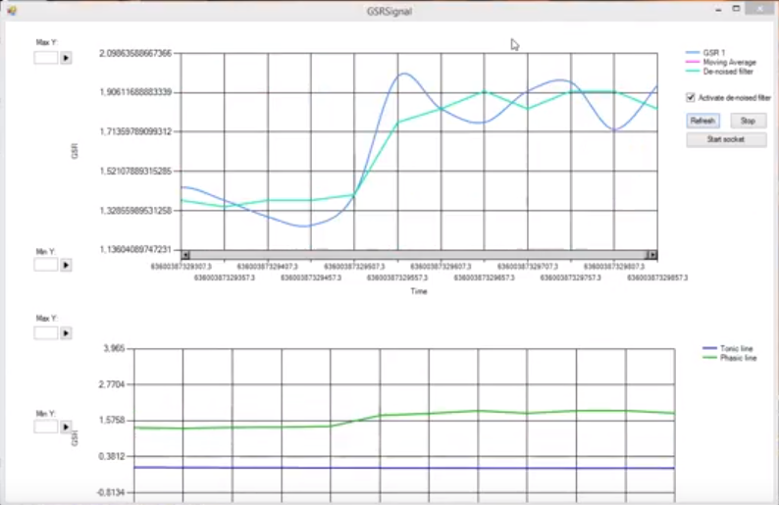

Fig. 28: EDA (GSR) signal visualized by the asset – raw (in blue) and filtered (in green) EDA signal (over) and tonic (in blue) and phasic (in green) signal (below)

The arousal level is applied for game adaptation purposes as follows:

* phasic arousal level is applied to correct (adapt) difficulty of the shooting and discovering tasks (together with the emotions inferred on facial expressions)
* tonic arousal level is applied to correct (adapt) difficulty of the puzzle solving tasks (because it indicates long-lasting changes in autonomic arousal of the player)

5.3 Gameplay adaptation based on player style

As explained in section 2.2, the STRAMAG game applies two ways of adaptive content selection based on the playing/learning style:

1. adaptive content selection of a didactic task in each of the maze rooms – for reaching better learning outcomes
2. adaptive content selection of an entertainment task in tunnels – for better playability

3.4 Strength and direction of the affective adaptation feedback

All the field trial games use an asset box positioned below in the center of the screen, containing textual information and buttons as follows:

* Number of collected gold bars in the “Rush for Gold” game
* Number of points in STRAMAG and the other two games
* Hints in “Rush for Gold” and STRAMAG game (fig. 8 and fig. 12)
*  button for starting and stopping music and audio-effects (fig. 29)
*  button for starting and stopping affective adaptation (based on player EDA and emotions)
*  button for evaluation of:
  + Affect-based adaptation method (using a 7 point Likert scale from “very bad” to “very good”)
  + Affect-based adaptation strength (using a 7 point Likert scale from “strong negative” to “strong positive”)

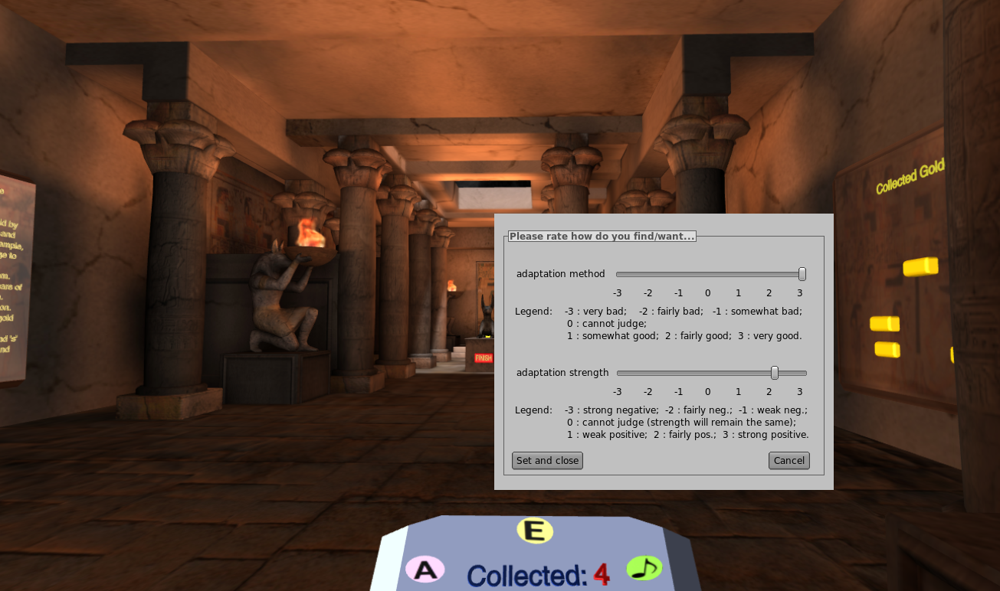

Fig. 29: Using the embedded real-time self-reporting tool and setting the strength of adaptation

In other words, the E button serves for instant real-time evaluation of the affect based adaptation and setting its strength. Note, that when setting the affective adaptation strength, the player in fact can change the direction of the feedback loop. Thus, we have positive and negative strengths of adaptation, as follows:

1. three positive strengths (weak, fair and strong positive) meaning that with increasing of player affect the game dynamic/aesthetic will increase as well, and vice versa
2. three negative strengths (weak, fair and strong positive) meaning that with increasing of player affect the game dynamic/aesthetic will decrease as well, and vice versa

By default, the strength of affective adaptation is set to +2 (positive moderate).

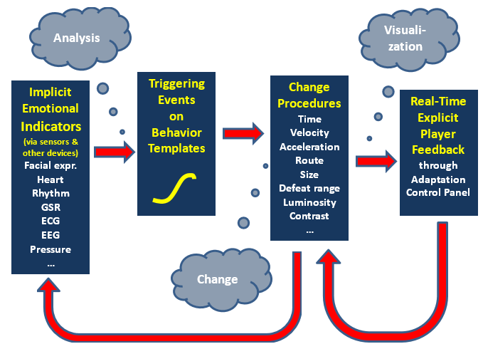

Fig. 30: ADAPTIMES workflow of emotion-based game adaptation control

Therefore, in contrast to the performance based adaptation and adaptation according to playing style, the affect-based adaptation is dynamic (i.e., with changeable both properties and rules!) and realises the workflow of emotion-based game adaptation control proposed in (ADAPTIMES D2, 2015) as presented in fig. 30.

# Calculation of playing styles

Playing styles are determined dynamically and implicitly during the game play. For this purpose, structured interviews with five Bulgarian entrepreneurs have been conducted through Skype in the time period between November 2015 and February 2016. The five entrepreneurs have experience in the area of ICT, logistics and organic supplement for more than 20 years. During the interviews, it was clarified that these playing styles share many common issues with similar types of workers in companies managed by these entrepreneurs. Their personal vision about the styles of Competitor, Dreamer and Logician were found to be dependent on both the performance and attitude of the workers including several issues:

* Effect of completed task (quantified result of accomplished work)
* Efficiency of task execution
* Difficulty of completed task

Additionally, a strategist is recognized by their strategic thinking and decision making. Here, entrepreneurs here counted with several indicators of efficient decision making, namely:

* relative task execution as an indicator of efficient decision making, i.e. time normalized according the maximal execution time
* average efficiency of all task execution
* average difficulty of all task execution
* metrics of planning
* metrics of plan monitoring
* effort put in task fulfilment

Therefore, the Competitor/Dreamer/Logician style appears to be dependent on several variables indicating execution of its respective task (shooting, discovering or solving puzzles):

* the percentage of collected gold bars of given type - shot, discovered or got by a solved puzzle (from 0 to 1) – normalized effect EFFnorm = Ncollected bars[10] / Nmax[11]
* average normalized efficiency (AEnorm) of execution of respective task of shooting, discovering or solving (from 0 to 1) – AEnorm = Nhits / Ntrials (from 0 to 1)
* average normalized difficulty (ADnorm) of completed respective task (from 0 to 1) – ADnorm = AD / Dmax [12].

The following formulas for the style calculation are applied:

* for bars of group A – this player is predominantly competitor (shooter) with rating   
  RC = kC1 * EFFCnorm + kC2 * AECnorm + kC2 * ADCnorm + kC4
* for bars of group B – this player is predominantly dreamer with rating   
  RD = kD1 * EFFDnorm + kD2 * AEDnorm + kD3 * ADDnorm + kD4
* for bars of group C – this player is predominantly logician with rating   
  RL = kL1 * EFFLnorm + kL2 * AELnorm + kL3 * ADLnorm + kL4

Here, kA4, kD4 and kL4 are linear regression constants (free polynomial members).

The Strategist playing style is inferred based on metrics of efficient decision making as explained over, namely:

* Relative game session time TRS = (SESSION_TIME_MAX+SESSION_TIME_MIN- task time) / SESSION_TIME_MAX * (Ncollected / 12)
* average efficiency of all task execution AEALL
* average normalized difficulty of all task execution ADALL
* relative number of planning events (changes in SMT divided to the max number of changes) - PE = NSMTchanges / NSMTchanges_max
* relative number of plan monitoring events (checks of SMT divided to the max number of checks) - ME = NSMTchecks / NSMTchecks_max
* average normalized effort in accomplishment of all the tasks – AEFFnorm = (NtrialsC + NtrialsD + NtrialsL) / 3 / AEFFmax

We have experimentally found (for preliminary experiments with N=8 subjects), that the maximum number of planning strategies for getting 12 golden bars in this game is equal to 3, and on the percentage of consultancies of SMT is no more than 2, as well. During the field trial, these numbers were found to be 3 an 4, respectively. Thus, the strategist player style equals

RS = kD1 * TRS + kD2 * AEALL + kD3 * ADALL + kD4 * PE + kD4 * ME + kD5 * AEFFnorm.

Table 1 represents the raw linear regression coefficients found during the structured interviews with the entrepreneurs. All of them will be subjects of statistical analysis in order to achieve best correlation with the questionnaire results.

Table 1: Raw coefficients

|  |  |  |  |  |  |  |  |
| --- | --- | --- | --- | --- | --- | --- | --- |
| **Style /  Coeff.** | **k1 [%]** | **k2 [%]** | **k3 [%]** | **k4 [%]** | **k5 [%]** | **k6 [%]** | **Total [%]** |
| Competitor | 40 | 30 | 30 |  |  |  | 100 |
| Dreamer | 40 | 30 | 30 |  |  |  | 100 |
| Logician | 40 | 30 | 30 |  |  |  | 100 |
| Strategist | 30 | 20 | 30 | 5 | 5 | 10 | 100 |

Besides the linear regression coefficients, during the analysis of the experimental results there will be found as well free terms.

# Targets of game adaptation

In order to improve the game playability, the player-centric basis for game adaptation will be used for three adaptation targets:

* **Game mechanics** - intelligent adaptation and adjustment of explicit, implicit, or player-driven game tasks and their managed appearance in the game flow, plus game content. Thus, tailoring game mechanics according the player model will aim at both pedagogical and entertainment goals
* **Game dynamics** - adaptation of tasks difficulty according to the player’s emotions (anxiety) and skill level - instead of supporting fixed difficulty levels, game difficulty may change accordance to player’s responses
* **Game aesthetics** - dynamic adjustment of audio-visual properties such as ambient light in the room, illumination/contrast/blurring/... of specific (manipulated) game objects, and/or sound level in the video game

Supposed improvement of game playability will be validated through post-play questionnaire, to be filled together with the already created playing style questionnaire.

Mapping of player-centric metrics to adaptable game metrics:

1. Emotional state: based on face expressions, there will be inferred the six universal basic Ekman emotions - [anger](https://en.wikipedia.org/wiki/Anger), [disgust](https://en.wikipedia.org/wiki/Disgust), [fear](https://en.wikipedia.org/wiki/Fear), [happiness](https://en.wikipedia.org/wiki/Happiness), [sadness](https://en.wikipedia.org/wiki/Sadness), and [surprise](https://en.wikipedia.org/wiki/Surprise_(emotion)) – plus the neutral one. For simplification, only happiness will be applied. A quantification approach will be used, where happiness (or surprise??) between 0% and 33% will be treated as low, between 34% and 66% - as moderate, and between 67% and 100% - as high happiness. The adaptive feedback will be combined: positive at low and moderate happiness and negative at high level of happiness. Embedded players help/feedback will be provided. Adaptable game metrics:

* Game dynamics - the velocity (both linear and angular) of the flying items; the navigation velocity while browsing, shooting precision, …
* Game aesthetics – illumination and contrast of flying items and rebus images; ambient illumination; sound level

1. Player's performance – represented by the AE for tasks of groups A, B and C. Combined feedback, applied together with the level of happiness. Adaptable game metrics:

* Game mechanics – easier or more difficult rebuses; adaptable help will be provided for hidden images and for the rebuses.

1. Playing styles – while recognising individual playing style, adaptive game mechanics will be realised, where the rule will be “Give to the player what he/she is interested, but not too much of it (apply the threshold)”. After finalising recognising the style, it will be used FT-2 for adaptive content selection within the maze and the embedded 3D quiz game.

# References

Jack, R. E., Garrod, O. G., Yu, H., Caldara, R., & Schyns, P. G. Facial expressions of emotion are not culturally universal. Proc. of the National Academy of Sciences, 2012, 109(19), pp.7241-7244.

…..

…..

(to be added)

1. http://adaptimes.eu/
2. The content validity of the questionnaire will be by evaluating of I-CVI and S-CVI/UA and Ave; its construct validity will be found by factor analisys.
3. Since no psychophysiological indices of flow experience are established, we will use subjective

   self-assessment tools and correlate the answers to the psychophysiological factors of flow within game sessions (e.g., (IJsselsteijn et al., 2008; Komulainen et al., 2008).
4. With EDA measurements that indicate player’s arousal and emotions inferred using face expressions, we are going to correlate emotional states of players to specific game events or game sessions similarly to (Nacke et al., 2008; Ravaja et al., 2008).
5. http://sightcorp.com/
6. http://rageproject.eu/
7. http://www.brainstorm.es/products/estudio/
8. http://www.affectiva.com/
9. http://rageproject.eu/
10. Collected bars for shooting, discovering or solving.
11. The maximum possible number of bars for shooting, solving or discovering is 6.
12. The maximal difficulty of accomplished tasks.